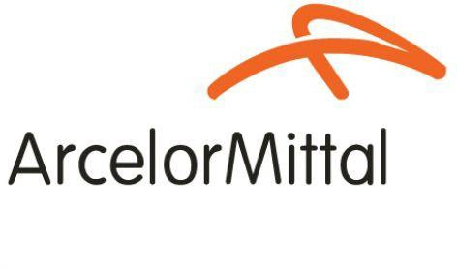
Procedure 2025

ArcelorMittal Building Solutions France Procedure 1.1.1.4

Edition of invoices

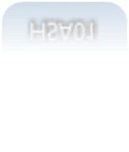
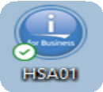
ENVELOPE INVOICES

Menu 03 / 06 / 03

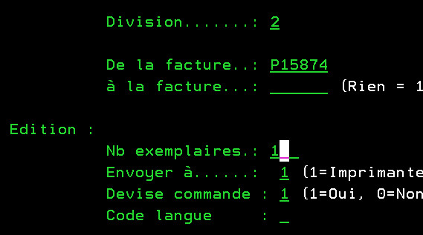
Always 2 (for AMC France)
Invoice number

Number of copies

F2 (validate)

FOLDING INVOICES

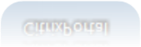
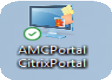
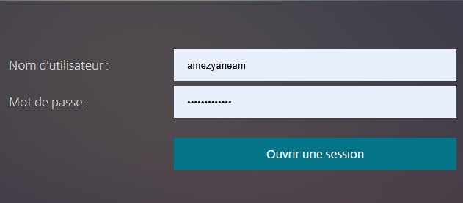

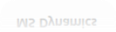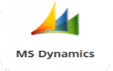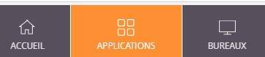

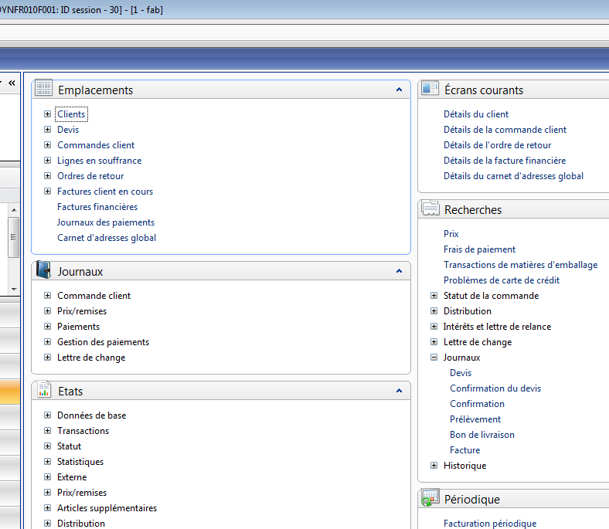
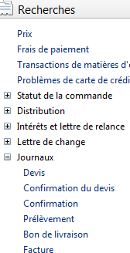
Use the "*" key to search as follows:

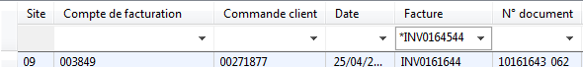
By invoice no

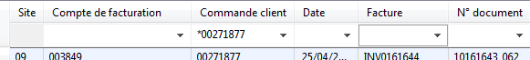
By order no

ENTER then "Preview / Print" (first tab on the right) and select "Copy preview".

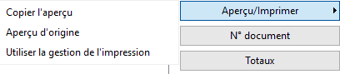
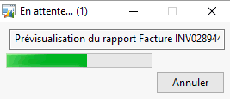

When the PDF opens, click on "Print file" / Properties :

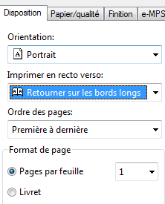
OK / PRINT

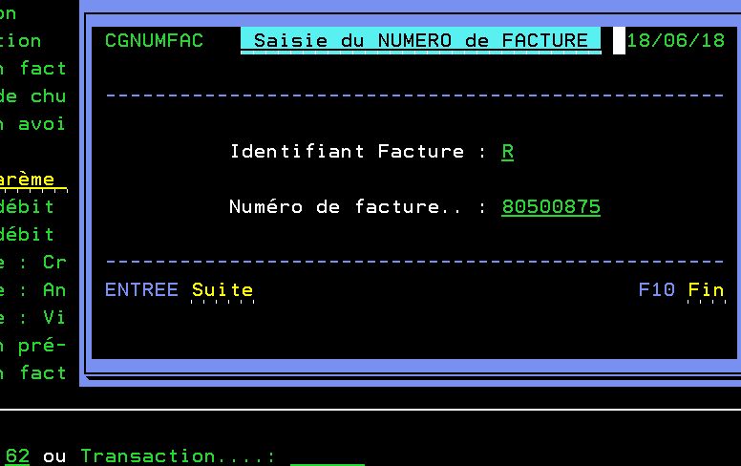


INVOICES “SI BOBINE”

Menu 10 / 02 / 62

Always R (reissue)
Invoice no. without SB

2 cases :
- A single invoice to be printed: ENTER then replace 62 by 36 for printing:
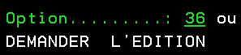

- Other invoices to be printed: ENTER then ENTER again to return to the screen above (leaving 62). Enter in the same way and repeat this procedure for each invoice.
Once all invoices have been entered, replace 62 with 36 to print all invoices at once.

D.COMPLEO
Open the COMPLEO link "Compleo Console - Connection" and log in.
Type the complete invoice number as shown below, then confirm:
View invoice
Electronic address (if filled in, sent by e-mail; if empty, sent by post)
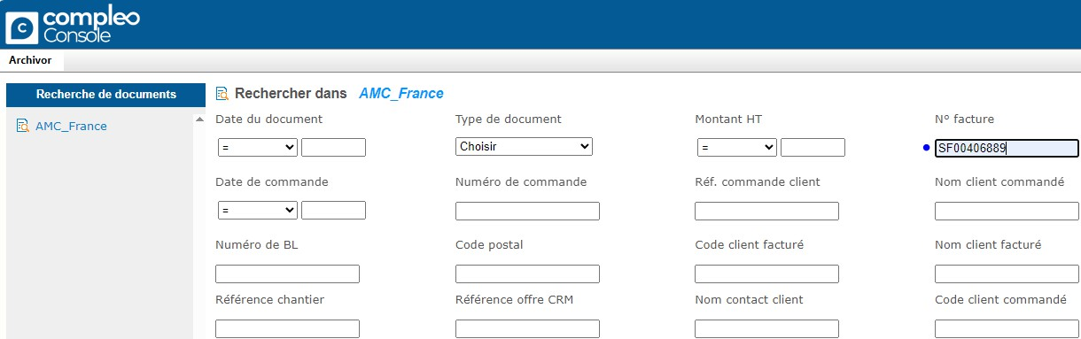

Save as PDF

On: 16/10/2025
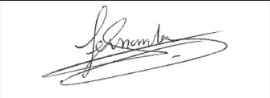
Procedure validated by : S. HERNANDEZ

